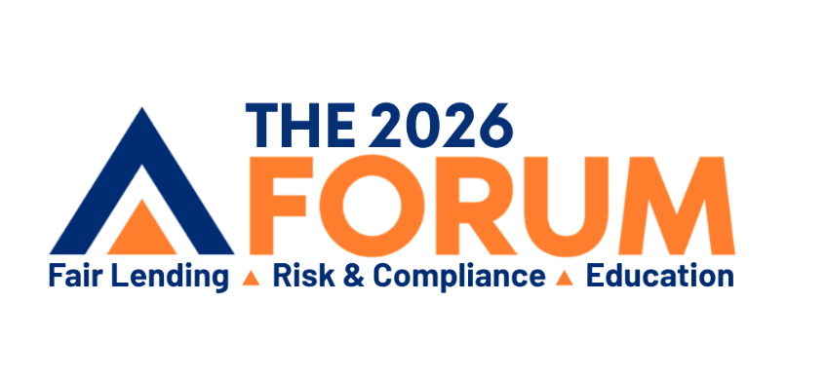
MAKING YOUR CASE TO ATTEND
Below is a sample letter to your leadership that will explain why your attendance at The
2026 Forum is a good investment.

Dear [Name],
I am writing to request your approval to attend The 2026 Forum, scheduled for Monday, April 20th – Wednesday, April 22nd in New Orleans, LA. As our industry continues to evolve, staying ahead of regulatory changes, best practices, and innovative solutions within the industry is crucial for maintaining our competitive edge and ensuring compliance.
Here are several compelling reasons why my attendance would be a valuable investment for our organization:
- Enhancing Compliance Knowledge
The 2026 Forum will feature expert speakers from regulatory bodies and industry leaders to legal experts who will provide insights into the latest regulations and enforcement trends. By attending, I will gain a deeper understanding of compliance requirements, which will help us mitigate future risks and avoid potential penalties.

- Learning Best Practices
The event offers numerous sessions focused on the latest best practices. These sessions will cover topics around areas such as CRA, Small Business Lending/1071, HMDA, Redlining, Fair Lending, Fair Servicing and more. Bringing these best practices back to our organization will enhance our strategies and improve our overall operational efficiency.

- Networking Opportunities
Attending The 2026 Forum will provide invaluable networking opportunities with peers, industry experts, and potential partners. Building these connections can lead to collaborative opportunities, sharing of insights, and potential partnerships that could benefit our organization in the long run.

- Staying Ahead of Industry Trends
The forum will showcase cutting-edge technologies and innovative solutions that can help us stay ahead in the industry. Learning about these advancements will allow us to explore new tools and strategies to enhance our practices and maintain our position in the market.

- Professional Development
Attending this forum will contribute to my professional growth and development. The knowledge and skills I will gain from this experience will not only benefit me but also empower me to contribute more effectively to our team and the organization as a whole. And by attending, I will receive continuing education credits.
I am confident that the insights and connections gained from attending The 2026 Forum will provide a significant return on investment for our organization. This conference is one of the most cost-effective, informative events in the industry. That said, to minimize the impact on our budget, I will ensure that I take advantage of any early-bird discounts. Also, there are registration rate discounts offered if there are 5 or more attendees from our organization.
Thank you for considering my request. I am eager to discuss how attending The 2026 Forum can align with our organizational goals and contribute to our continued success.
Sincerely,
[Your Name]
[Title]

